**Chapter 3**

**Vector-Valued Functions**

**3.1 Vector-Valued Functions and Space Curves**

**Section Exercises**

1. Give the component functions  and  for the vector-valued function 

Answer: 

3. Sketch the curve of the vector-valued function  and give the orientation of the curve. Sketch asymptotes as a guide to the graph.

Answer:

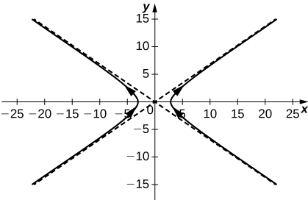

5. Given the vector-valued function  find the following values:

1. 
2. 
3. Is  continuous at 
4. Graph 

Answer: a.  b.  c. Yes, the limit as *t* approaches  is equal to  d.

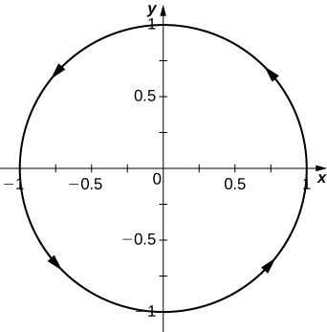

7. Let  Find the following values:

1. 
2. 
3. Is  continuous at *t=*

Answer: a.  b.  c. Yes

**Find the limit of the following vector-valued functions at the indicated value of *t*.**

9.  for 

Answer: 

11. 

Answer: 

13.  for 

Answer: The limit does not exist because the limit of  as *t* approaches infinity does not exist.

**Find the domain of the vector-valued functions.**

15. Domain: 

Answer:  where k is an integer

17. Domain: 

Answer:  where *n* is an integer

**Let  and use it to answer the following questions.**

19. Sketch the graph of 

Answer:

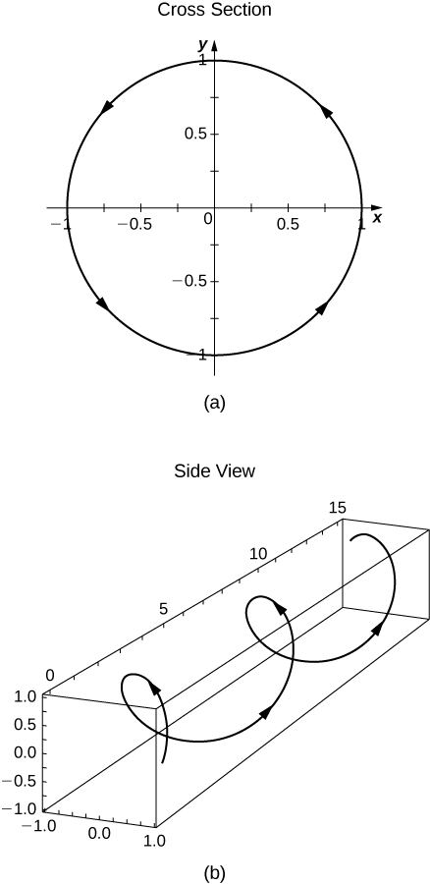

21. For what values of *t* is  continuous?

Answer: All *t* such that 

**Eliminate the parameter *t*, write the equation in Cartesian coordinates, then sketch the graphs of the vector-valued functions. (Hint: Let  and  Solve the first equation for *x* in terms of *t* and substitute this result into the second equation.)**

23. 

Answer:  a variation of the cube-root function

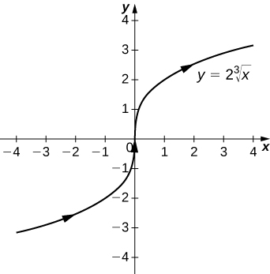

25. 

Answer:  a circle centered at  with radius 3, and a counterclockwise orientation

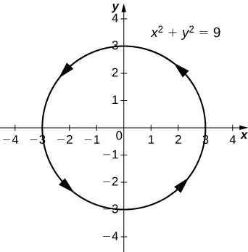

**Use a graphing utility to sketch each of the following vector-valued functions:**

27. **[T]** 

Answer:

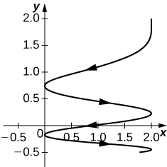

29. **[T]** 

Answer:

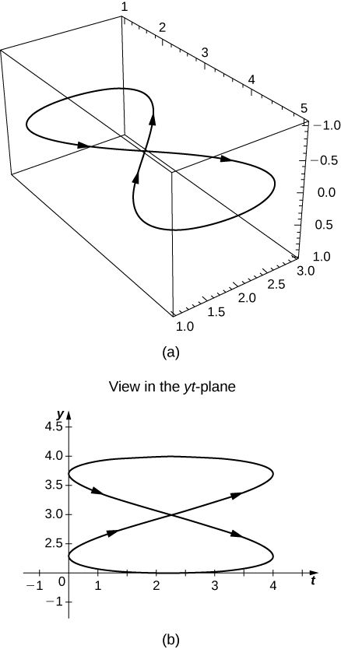

**Find a vector-valued function that traces out the given curve in the indicated direction.**

31.  from left to right

Answer: For left to right,  where t increases

**Consider the curve described by the vector-valued function **

33. What is the initial point of the path corresponding to 

Answer: 

35. **[T]** Use technology to sketch the curve.

Answer:

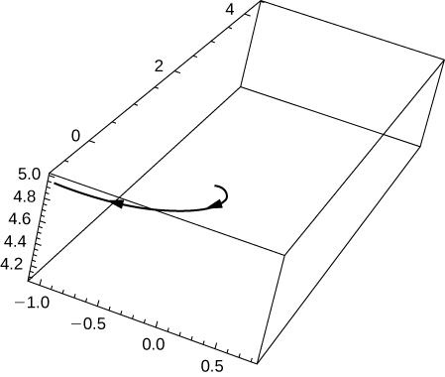

37. **[T]** Let . Use technology to graph the curve (called the *roller-coaster curve*) over the interval  Choose at least two views to determine the peaks and valleys.

Answer:

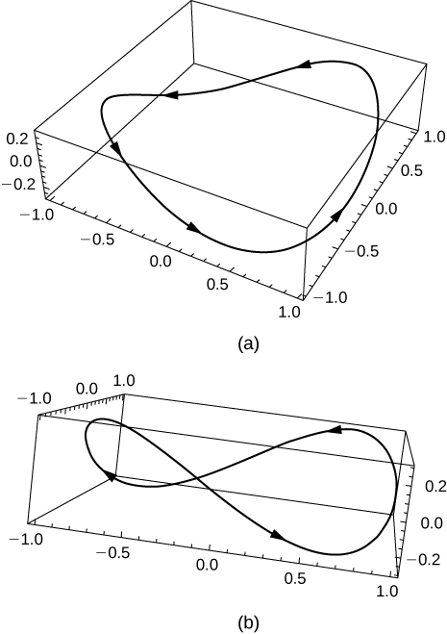

39. Use the results of the preceding two problems to construct an equation of a path of a roller coaster with more than two turning points (peaks and valleys).

Answer: One possibility is  By increasing the coefficient of *t* in the third component, the number of turning points will increase.

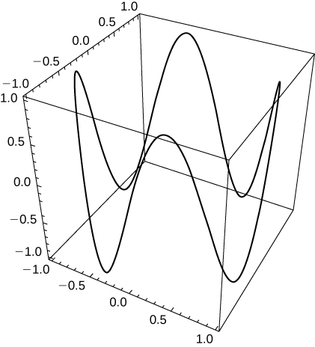

This file is copyright 2016, Rice University. All Rights Reserved.